**What Is a Time Series?**

Time series is a type of data set in which we observe one or more events or variables over a period of time intervals. These time intervals are mostly equally spaced (hourly, daily, weekly, monthly, quarterly, etc.). We use time series to analyse trends and patterns over time.

An important feature to be analysed in a Time Series is the seasonality. This is the characteristic of a Time Series having a default behaviour within a certain time interval. If this pattern is repeated within the same interval over time then we will have the presence of a sample with a seasonal behaviour.  
The Statsmodels library helps us perform this analysis with great ease, but first, let’s understand what the analysis features of a Time Series are.

* **Level**: is the average value in the series.
* **Trend**: is the increasing or decreasing value in the series.
* **Seasonality**: is the repeating the short-term cycle in the series.
* **Noise**: is the random variation in the series.

There are basically two methods to analyse the seasonality of a Time Series: additive and multiplicative.

* The Additive Model –

y(t) = Level + Trend + Seasonality + Noise

* The Multiplicative Model

y(t) = Level * Trend * Seasonality * Noise

**Decomposition as a Tool**

Decomposition is primarily used for time series analysis, and as an analysis tool it can be used to inform forecasting models on your problem.

It provides a structured way of thinking about a time series forecasting problem, both generally in terms of modeling complexity and specifically in terms of how to best capture each of these components in a given model.

The statsmodels library provides an implementation of the naive, or classical, decomposition method in a function called seasonal_decompose(). It requires that you specify whether the model is additive or multiplicative.

Simply put, this method assumes the components of time series are additive/multiplicative, meaning that they can be added/multiplied together to produce the original time series. Additive decomposition method is typically used when the trend and seasonality component stay constant over the period of time and multiplicative decomposition is used if they are increasing or decreasing over time.

A review of a plot of the time series and some summary statistics can often be a good start to get an idea of whether your time series problem looks additive or multiplicative.

We will be looking at two datasets Sunspots and Air Passengers for our analysis.

* Sunspots dataset

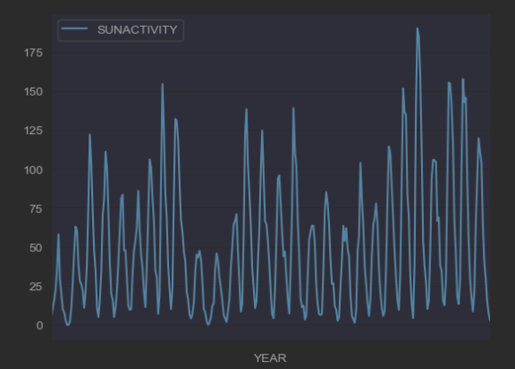

The sunspot data shows no obvious increasing and decreasing trend over more than two and a half centuries, but it seems that the peaks is pretty regular which shows indication of seasonality, for that reason we are going to use the Additive method of decomposition, also if we look carefully at the plot will noticed some zero outliers which cannot be used in Multiplicative model.

* Air Passenger dataset

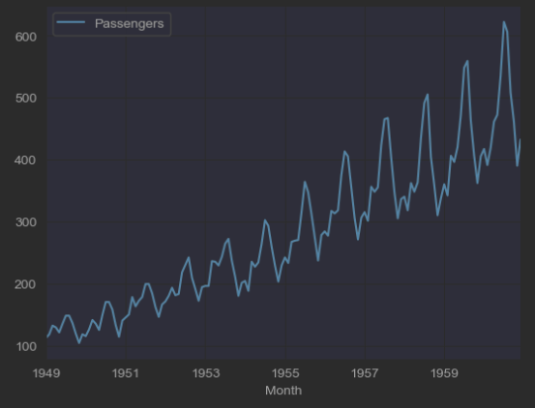

if we look at the above time series chart you can see it has an upward trend but also has some seasonality to it. It would be helpful if we can decompose this time series to its constituents. The upward trend gives us indication to use the Multiplicative Model, also we can add Additive Model because of a present of some seasonality.

* Decomposition of Sunspots dataset

Usually the additive period is 7, so let’s use it here.

seasonal_decompose(sunspots, model='additive', period=7)

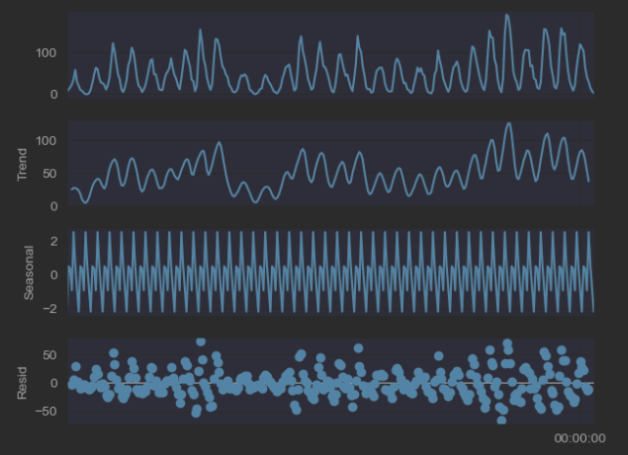

The trend, seasonality, and remainder all still show repeated patterns which mean that there is still a seasonality we have not captured. Let’s make the frequency to be 11 years as suggested by literature.

The sunspots are, after all results of the sun’s magnetic activity. This 22 year cycle will be added to the 11 year cycle.

seasonal_decompose(sunspots, model='additive', period=11)

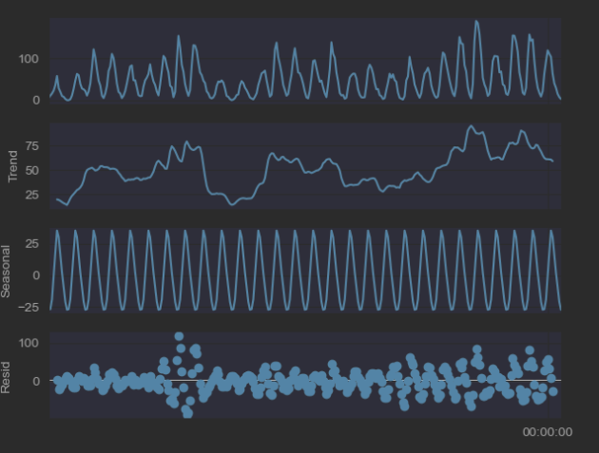

We clearly see a change in the trend with no visible seasonality.

* Decomposition of Air Passenger dataset
  + Additive Method Decomposition

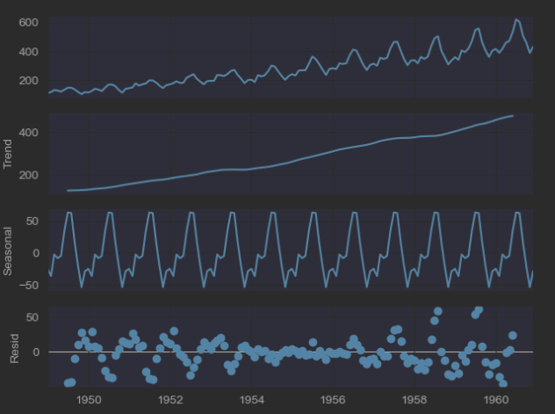

* + Multiplicative Method Decomposition

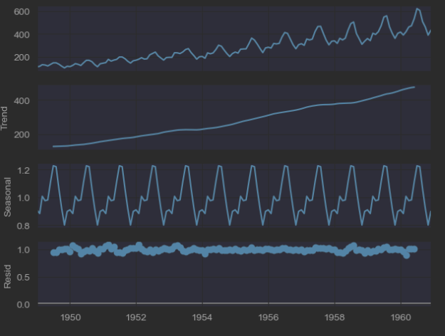

We can see that the air trend and seasonality information extracted from the series does seem reasonable. The residuals are also interesting, showing periods of high variability in the early and later years of the series.

Hey Jim,

There is some common feature between the trends of both datasets and that is the seasonality, although the air passenger trend is upwards there is some embedded seasonality, which makes it more interesting is to use Multiplicative Model for upwards movement, and Additive Model for the seasonality features.

I think they have chosen those particular datasets on purpose. You cannot use Multiplicative Model on sunspots datasets, because of some zero outliers, just to see the difference.

Hey Paul,

Good analysis, just to add in sunspots datasets there are 11 cycles so 12 periods make sense and using the Additive Model, if you have used 7 periods which is the default and 12 periods you will see clear difference at seasonality of the trend

Hey Vincent,

Good analyses as usual. Just to add up on the technical site, what is in interesting in that trend is you can use both decompositions Multiplicative Model for upwards movement, and Additive Model for the seasonality features